Quality Policy

DEE Inc. is committed to exceeding customer requirements by providing technical assistance and on-time delivery of the highest quality products available in the aluminum casting and machining industry.

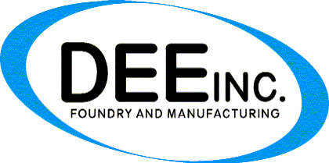We view our customer relationship as a
partnership.

We will adapt to our customer's changing
needs at all times in an environment of
continuous improvement.

We are dedicated to be an industry leader in
product quality, competitive pricing and
innovation in all of our business practices.

We are committed to satisfying all statutory, regulatory and customer requirements.

