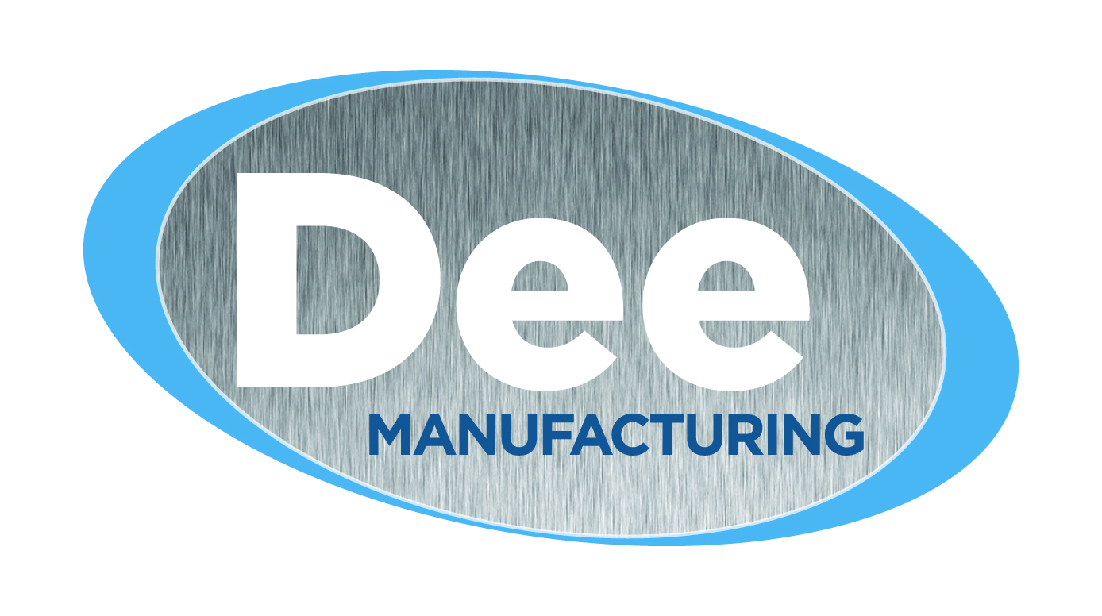

Supplier Quality Manual

1/19/26

Dee Manufacturing LLC
1302 Foskett St.
Crookston MN, 56716
Table of Contents

Section Title Page

1.0 Dee Manufacturing LLC, Supplier Quality 4
1.1 Supplier Relationships 4
1.2 Responsibilities 4
1.3 Social Responsibility 5
1.4 Statutory and Regulatory Compliance 5
1.5 Process Changes 6

2.0 Supplier Selection, Approval and Performance 6
2.1 Supplier Quality Management System Requirements 6
2.2 Supplier Selection Process 6
2.3 Approved Supplier 7
2.4 Loss of Approved Status 7
2.5 Supplier Performance Evaluation 7

3.0 Supplier Quality System Requirements 8
3.1 Documented Quality System 8
3.2 Document and Record Retention 8
3.3 Manufacturing Process Design 8
3.4 Drawing and Specification Control 8
3.5 Control of Subcontracted Materials and Services 8
3.6 Manufacturing Process Control 8
3.7 Final Inspection and Test Plans (as applicable) 9
3.8 Product Status Control 9
3.9 Inspection and Testing Equipment Control 9
3.10 Defective Product/Material Control 9
3.11 Corrective Action 9
3.12 Quality Cost Analysis 9
3.13 Fallout Analysis 10
3.14 Customer-Owned Material 10
3.15 Quality System Audit 10
3.16 Continuous Improvement 10

4.0 Product & Process Control (Customer Specific Requirements) 10

5.0 Product Quality Planning 10

6.0 Production Part Approval Process (PPAP) Requirements 11

7.0 Supplementary Quality Requirements 11

8.0 Production Control Plan 11

9.0 Manufacturing Capabilities 11

10.0 Supplier Development 12

11.0 Additional Information 12

12.0 Acknowledgement Page 12

APPENDIX
Appendix I (Confidentiality Agreement) 14
Appendix II (Supplier Code of Conduct / Social Responsibilities) 15
Appendix III (Chargeback Policy) 18
Appendix IV (New Supplier Survey) 19
Appendix V (Scorecard) 20
Appendix VI (Sample Production Control Plan) 21
Appendix VII (Sample Process Failure Mode and Effects Analysis (PFMEA) 22

13.0 Revision Page 23

1.0 Dee Manufacturing LLC Supplier Quality
This document defines the Dee Manufacturing LLC supplier quality requirements. The primary objective of our supplier quality program is to secure world-class quality in purchased materials and services. This will enhance the quality of Dee Manufacturing LLC products and reduce costs through reduced inspection, test, rework, and handling.

1.1. Supplier Relationships
To achieve this objective, Dee Manufacturing LLC and its suppliers must forge the kind of relationship that permits the attainment of superior quality. This necessitates a relationship that breaks with tradition – one built on mutual respect and cooperation; one aimed at mutual benefit and prosperity.

In this relationship, Dee Manufacturing LLC gains by avoiding the time and expense associated with changing suppliers. The Dee Manufacturing LLC supplier gains by getting first consideration for new business. And both organizations benefit from the stabilizing influence and increased opportunity of a long-term business relationship.

Dee reserves the right to visit and/or audit its suppliers. These visits/audits will be coordinated with the supplier in advance. Suppliers are expected to support this activity.

Suppliers wishing to visit Dee are encouraged to do so. This type of visit should be coordinated through the Sales Department or Quality Assurance, depending on the purpose of the visit. Visitors must sign the Visitor Log at the front desk after reviewing the Visitor Safety Policy. Steel-toed shoes, eye protection and hearing protection are required.

1.2. Responsibilities

Dee Manufacturing LLC
As a Dee Manufacturing LLC supplier, you can expect clear, concise requirements for purchased material and services. That means discussions about design and processing early in the development of new products or processes. You can expect Dee engineering changes to be communicated in a timely manner, recognizing supplier lead-time requirements. Suppliers must be provided with immediate feedback regarding quality and delivery.

It is Dee Manufacturing LLC’s responsibility to back ideas for quality improvements, cost reductions and other suggestions, with adequate engineering and test support.

Dee Manufacturing LLC pledges the support of its management to work in a cooperative effort to provide a mutually satisfactory business relationship.

Dee Manufacturing LLC will also communicate any special requirements regarding supplier knowledge, competencies, or qualifications of its employees.

Supplier
Dee Manufacturing LLC expects strict compliance with print and other specifications.

Supplier is responsible for developing and maintaining an effective Quality Management System (QMS) to ensure Dee Manufacturing LLC receives defect-free materials and services on time. Details of these requirements are listed below.

Supplier shall have a risk-based approach to maintaining business continuity, ensuring product conformity and uninterrupted supply with planned and implemented action to address risks, opportunities, and contingencies.

Supplier must remain competitive in pricing, service and delivery. Dee Manufacturing believes suppliers should be a source of cost reduction ideas, the benefits of which will be shared.

All Dee Manufacturing LLC specifications, drawings and technical data are considered confidential. Suppliers will treat this information with strict business confidence, and no disclosure will be made, in any form, to third parties. In certain cases, as determined by Dee, it may be necessary to complete and sign a formal Confidentiality Agreement. (Appendix I)

1.3. Supplier Code of Conduct / Social Responsibilities
As Dee Manufacturing continues to globalize our business and supply base, we realize evaluating the environmental performance and social integrity of our suppliers is increasingly important to ensure our values are protected. As a result, Dee requires supplier commitment to sound business ethics, environmental responsibility, workforce treatment and safety as well as to adhere to our Supplier Code of Conduct / Social Responsibilities (Appendix II).

1.4. Statutory and Regulatory Compliance
As an extension of Dee’s global business, suppliers may be required to provide evidence of conformance to specific industry, customer, statutory and regulatory requirements. As directed by Dee, conformance may include requirements applicable to the country of receipt, the country of shipment and, if provided, the customer country of destination.

Compliance certification examples include, but are not limited to: International Traffic in Arms Regulations (ITAR), Export Administration Regulations (EAR), North American Free Trade Agreement (NAFTA), Restriction of Hazardous Substances (RoHS), Registration, Evaluation, Authorization and Restriction of Chemicals (REACH), Conflict Minerals, Material Certificates, Shipping Certificates, Certificates of Conformance, Diversity Statement, etc.

Quality Management System certification examples include, but are not limited to, ISO 9001, IATF 16949, ISO/IEC 17025, ISO 14001, etc.

1.5. Process Changes
The supplier is encouraged to pursue and implement changes to their processes and manufacturing systems to improve quality, efficiency, logistics and costs. The supplier is required to inform Dee Manufacturing of any process change that affects customer requirements. This includes moving the location of production equipment. Process changes shall include a production trial run, and the results of the trial shall be documented.

2.0 Supplier Selection, Approval and Performance

2.1 Supplier Quality Management System Requirements
In most cases, third party registration to IATF 16949 is required for suppliers providing products/materials/services for Dee’s automotive customers. Third party certification to IATF 16949 must be conducted in compliance with the International Automotive Task Force (IATF) recognized automotive certification scheme by a certification body recognized by the IATF.

As a minimum, for identified suppliers of automotive products/materials/services, third party registration to ISO 9001 and completion of the Minimum Automotive Quality Management System Requirements (MAQMSR) for Sub-Tier Suppliers self-assessment along with a commitment to supplier development to the IATF 16949 automotive standard is required (see 10.0 Supplier Development).

Dee Manufacturing does not require all suppliers to be registered to an International Quality Standard. Generally speaking, however, suppliers are required to maintain a quality management system that conforms to the current ISO 9001 Quality Management System (QMS) standard. See 3.1 through 3.16 for QMS element descriptions.

In certain instances, where a supplier may be too small to justify a formal quality system, supplier approval will be limited in scope and selection of non-critical product/materials/services provided. In those instances, verification shall be made to ensure a supplier’s ability to comply with the requirements of section 3. 0..

Suppliers are requested to send updated quality certifications to your Dee Quality Assurance (QA) contact.

2.2. Supplier Selection Process
Dee Manufacturing uses a structured approach for new supplier selection. Suppliers are evaluated based on their ability to provide products/materials/services that meet customer requirements, can be delivered on time, and is cost-effective.

Suppliers of automotive products/materials/services will be required to meet additional automotive industry and customer specific requirements. As a part of our supplier selection process, additional information will be required as a part of Dee’s evaluation. The type of information may include, but not limited to; volume of automotive business, financial stability, product/material/service complexity, required technology, adequacy of available resources, design and development capability, manufacturing capability, change management process, business continuity planning, logistics process, customer service process, and statutory/regulatory compliance, etc.

2.3. Approved Supplier
An “approved” supplier must have an acceptable quality system in place. Verification of this is normally done with evidence of a third-party registration traceable to the ANSI National Accreditation Board (ANAB) and/or discussions with the supplier. The supplier’s business direction, philosophies and financial posture must also be compatible with Dee Manufacturing’s.

For suppliers of automotive products/materials, a more in-depth evaluation is conducted which will require the completion of the New Supplier Survey (Appendix IV).

A supplier may be conditionally approved at discretion of Dee Manufacturing. Reasons or conditional approval prior to full approval may include: supplier improvement on its overall QMS, process capability or capacity, quotation, and cost justification/comparison. Only an approved supplier is awarded purchase contract(s).

2.4 Loss of Approved Status
Suppliers scoring 80% or higher in a 12-month period retain their approved supplier status.

Suppliers with a score of less than 80% in a 12-month period are issued a corrective action request and placed in a conditional status. Suppliers remain in a conditional status until an 80% score or higher is attained.

Suppliers failing to meet the following criteria could jeopardize the approved status and
continued business:
- Maintain an approved plan for quality.
- Quality performance.
- Delivery performance.
- Technological support and participation.

Deliveries are considered late if they are more than 5 days early or more than 5 days late.

2.5. Supplier Performance Evaluation
Dee Manufacturing LLC uses a program of rating the performance of select suppliers on quality and delivery. The performance reports are generated semi-annually for suppliers who provide products or services that directly impact part quality and annually for suppliers who provide products or services that directly impact the production process. If performance criteria are not met as specified, the supplier may be required to submit a corrective action. Results of supplier ratings and corrective action responses are used to monitor the suppliers’ ability to continue to meet requirements, determine future business relationships and for further supplier development.
Performance rating criteria is shown in Appendix V (Scorecard).

3.1. Documented Quality System
Quality system elements accepted by the industry as necessary for the consistent production of conforming material must include those listed below. In addition, Supplier’s quality system and procedures must be in written form and available upon request.

3.2. Document and Record Retention
A documentation control system is also part of an effective quality management system that includes record retention and retrieval that meets requirements of Dee Manufacturing, its Customers and Regulatory agencies.

3.3 Manufacturing Process Design
Supplier is expected to have a means of demonstrating their ability to meet process design objectives and reliability requirements. Such means would include statistical methods, Failure Mode and Effect Analysis (FMEA) and others.

3.4. Drawing and Specification Control
There must be a documented system for assuring that only the latest engineering drawings and specifications are available for manufacturing and inspection. Supplier must maintain a record of date changes are made. Deviations or supplier changes affecting Dee Manufacturing specifications and design intent must have Dee approval prior to being implemented.

3.5. Control of Subcontracted Materials and Services
Supplier is responsible for ensuring that all products and services it purchases conform to Dee specification requirements including compliance expectations per Section 1.4. Supplier’s system must include procedures to carry out this responsibility.

3.6. Manufacturing Process Control
Process control requirements are important and are to be based on the idea of prevention rather than detection. They must include a method of detecting/preventing defective material to the extent possible and identifying and segregating nonconforming product/material to protect the customer. Such systems employ written setup instructions, sufficient gages, or test equipment for the operator to know when the material is within specifications and the ability to control the output and acceptance criteria including acceptable limits and frequencies.

The supplier shall provide measurement, test and inspection data that demonstrate that the control plan requirements, samples sizes, and frequencies are being met when requested. Sample sizes and frequencies shall be determined based on risk, occurrence of failure modes, and volume to ensure that Dee is adequately protected from receiving defective products/materials/services. The use of statistical process control is strongly encouraged as are automated means of process control.

Error proofing methods shall be implemented where feasible and listed in the FMEA.

3.7 Final Inspection and Test Plans (as applicable)
Final inspections and dock audits are components of a sound quality management system. Final inspections and dock audits must have written instructions and records must be maintained.

3.8. Product Status Control
Methods must be employed to maintain positive identification of materials, both in process and finished. Both material identification and quality status must be readily identifiable (i.e., conforming, scrap, rework, etc.) through all stages of the process.

3.9. Inspection and Testing Equipment Control
Supplier must provide and maintain adequate inspection and test equipment to provide process control. Supplier must calibrate inspection equipment with methods that are traceable to the National Institute of Standards and Technology (NIST). Suppliers who use outside organizations for calibration or testing must ensure that they are certified to ISO/IEC 17025 as a part of their supplier control system.

A program must be developed and implemented to verify the accuracy of inspection and test devices at periodic intervals to ensure continued accuracy.

3.10 Defective Product/Material Control
Manufacturing controls must include provisions for identification and isolation of suspected defective material. These activities include verification of material in the flow stream. Reworked material must be reinspected or retested to ensure all characteristics meet specification.

Material not conforming to specifications must be referred to Dee Manufacturing Quality Assurance (QA) for review and disposition. In general, parts dispositioned as scrap are required to be returned to Dee. Refer to the Chargeback Policy for further explanation and exceptions (Appendix III).

3.11. Corrective Action
When nonconforming material is identified by Dee, the supplier may be required to submit a documented corrective action. The corrective action format must include (at minimum) all steps directed by Dee. Corrective actions must also be verified for effectiveness.

Unless otherwise specified in the corrective action request, an initial response and containment is required within 24 hours. Verification and closure should be completed within 30 calendar days. Contact Dee Quality Assurance for corrective actions requiring more than 30 calendar days.

3.12. Quality Cost Analysis
Supplier is expected to record quality-related costs and use the data for improving the process and operation. These costs normally include scrap, rework, and other failure costs.

3.13. Fallout Analysis
Failure data, whether from customer feedback or in-house, is another internal measurement that shall be used to improve processes and reduce defects.

3.14 Customer-Owned Material
Supplier must have facilities and methods to protect and preserve customer-owned inventory, tooling, gaging and other materials.

3.15. Quality System Audit
There must be a periodic audit of internal processes to verify that the quality management system procedures and work instructions are being followed. Results of audits must be documented and used to drive corrective action and continuous improvement.

3.16. Continuous Improvement
Continuous improvement efforts are expected and can be accomplished in many ways. But these always involve a structured approach, management and workforce participation, a plan/do/check/act type methodology and produce results that can be measured.

4.0 Product & Process Control (Customer Specific Requirements)
Along with implementation of the quality described in section 3.0, the supplier may be asked to submit a detailed plan, with supporting documentation, for controlling the quality of products/services/materials. Due to Dee’s diverse customer base, the extent of process planning, sampling and support documentation will vary.

Supplier participation in Advanced Product Quality Planning (APQP), Production Part Approval Process, (PPAP), as well as evidence of conformance to AIAG special process assessments (CQI’s), may be required. These requirements, as well as other customer specific requests, must be complied with.

Key characteristics shall be identified in control plans, FMEA’s and work instructions and shall be used to control the production process with documented evidence of conformity maintained as a record.

5.0 Product Quality Planning
A structured method of defining and establishing the process steps needed to meet requirements is required. Planning is to be achieved during the quotation / supplier selection processes and as much detail as possible needs to be communicated so that Dee Manufacturing can make informed decisions.

Aside from the routine understanding of the service provided, it may be necessary for the supplier to participate in providing input/output in formal program planning. As determined by the program requirements, this participation may be required so that all requirements are known and agreed to, timing of product/process development is communicated, and process/product design is aligned with that of Dee and the customer. The AIAG defined Advanced Product Quality Planning (APQP) process is used as a guide to this activity.

6.0 Production Part Approval Process (PPAP) Requirements
It is important to begin production of a new component with total compliance with the product/service/material specifications. For this reason, we may ask that the supplier submit inspection and, if supplying production parts, samples for that purpose. This practice aids in verifying tooling, process/ measurement methods, and process compatibility.

While it is understood that every effort will be made in process design to ensure a quality product is supplied, supporting data and/or information may be required. The AIAG defined Production Part Approval Process (PPAP) may be required. In such cases, it is the responsibility of the supplier to become familiar with these requirements and terminology and have the ability to provide the necessary information. PPAP documentation will require, in addition to the initial sample inspection report, related data such as control plans, flow charts, Process Failure Mode and Effects Analysis (PFMEA) and capability studies on critical characteristics. General PPAP requirements can be found on the Dee Purchase Order. Specific PPAP requirements, including the PPAP level, will be supplied by Dee Quality Assurance. See Appendix VI for a sample Production Control Plan. See Appendix VII for a sample PFMEA.

7.0 Supplementary Quality Requirements
Suppliers may be required to comply with International Traffic In Arms Regulations (ITAR) and/or Export Administration Regulations (EAR), including registration with the State Department or Commerce Department to provide products/materials/services.

Suppliers may be required to create components/materials in the International Material Data System (IMDS) and/or the Compliance Data Exchange (CDX).

Suppliers may be required to complete Automotive Industry Action Group (AIAG) Special Process Assessments (CQI Assessments) with copies provided to Dee.

8.0 Production Control Plan
Preferred Production Control Plans consist of a block diagram or other suitable description of the process, identified points where the material is checked or tested for purposes of controlling the process and important control mechanisms in the process itself which must be maintained for consistent output.

Test and inspection points, methods and equipment are identified along with inspection frequencies, sample sizes, and data to be recorded. This plan is a key element for assuring conformance to specifications.

9.0 Manufacturing Capabilities
An integral part of an effective and efficient quality operation is the activities associated with planning and development of processes, facilities, and equipment. The supplier must employ a systematic approach to addressing these issues in advance of actual implementation. Also included in these efforts are activities such as Process Failure Mode and Effect Analysis (PFMEA), mistake proofing, tool and gage development and a formal tool management program that includes identification, storage, set-up, and tool change programs.

10.0 Supplier Development
Dee Manufacturing is committed to assisting its suppliers in developing a quality management system which includes implementing quality improvement activities that conform to International Standards.

Dee develops automotive suppliers by determining the priority, type, extent, and timing through documented development plans. Suppliers are an integral part of developing these plans and their timing. Development may also include additional certification requirements and/or audits performed by Dee.

11.0 Additional Information
Please refer requests for clarification of requirements or other information to your Dee Manufacturing buyer and/or quality assurance.

12.0 Acknowledgement Page

DEE MANUFACTURING LLC
1302 Foskett St. Crookston, MN 56716 U.S.A. 218.280.1987 FAX 218.280.7321

I, (print name) __________________________, (title) ______________________ on behalf of,
(company name) ______________________ located at (address) _______________________,
have read, understand, and agree to abide by Dee Manufacturing LLC’s Supplier Quality Manual and its relevant Appendixes. I also agree to inform and implement these same standards for our sub-suppliers in all applicable situations.

Supplier Rep. Signature: ____________________________________ Date: _______________

Agree/Disagree Document

☐ ☐ Supplier Quality Manual
Note/Exception:

_____________________________________________________________________________________

☐ ☐ Confidentiality Agreement (Appendix I)
Note/Exception:

_____________________________________________________________________________________

☐ ☐ Supplier Code of Conduct / Social Responsibilities (Appendix II)
Note/Exception:

_____________________________________________________________________________________

☐ ☐ Supplier Charge Back Policy (Appendix VII)
Note/Exception:

_______________________________________________________________________

Any questions or comments please do not hesitate to reach out. When there is a concern with meeting or abiding by any of these requirements, Dee Manufacturing LLC’s practice is to ultimately work for resolution with you, our supplier. In the rare instance where an issue cannot be corrected, is a violation of law or you are unwilling to engage in improvements, we reserve the right to terminate our business relationship.

Sincerely:
GM, Dee Manufacturing LLC
Appendix I (Confidentiality Agreement)

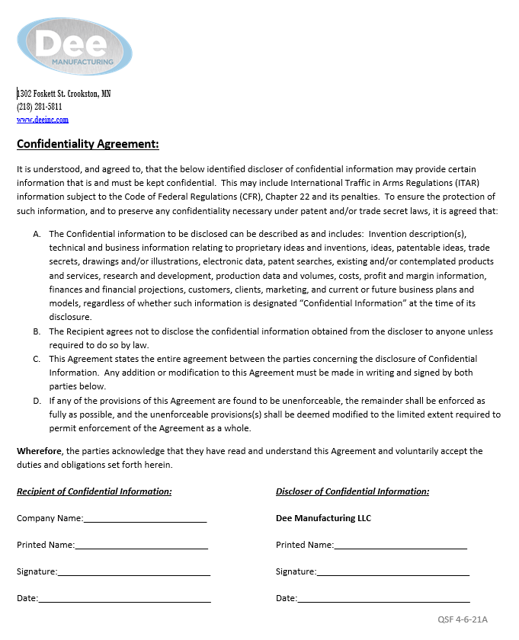
Appendix II (Supplier Code of Conduct / Social Responsibilities)

Supplier Code of Conduct / Social Responsibilities

Purpose
This Code of Conduct, with respect to Social Responsibilities, defines the basic requirements placed on Suppliers and their Sub-Suppliers concerning responsibilities toward all business activities and practices.

Scope
The requirements as stated relate to suppliers that provide products or services to Dee Manufacturing LLC.

• Legal compliance
o To comply with all laws and regulations of the legal systems that apply to suppliers, subsidiaries, divisions, or their affiliates.
• Prohibition of corruption, kickbacks, and bribery
o To not tolerate any form of corruption, kickback, or bribery and to not grant, offer, or promise anything of value to a government official, sub-supplier or customer to influence official action and/or to obtain an improper business advantage.
• Anti-trust laws and intellectual property rights
o To act in accordance with national and international competition laws and not to participate in price fixing or market sharing with its competitors.
o To respect the intellectual property rights, trade-secrets and financial information of its customer and others.
• Conflicts of interest
o To avoid all conflicts of interest that may adversely influence business relationships with customers and competitors.
• Respect for the human rights of employees or applicant for employment
o To promote equal opportunities for, and treatment of, its employees or applicant of employment irrespective of race, creed, color, religion, sex, sexual orientation, age, marital status, disability, national origin, military and veteran status or any other characteristic protected by law.
o To respect the personal dignity, privacy and rights of each individual.
o To not tolerate any unacceptable treatment of employees, such as mental cruelty, sexual harassment, or discrimination.
o To provide fair remuneration and to guarantee the applicable national statutory minimum wage.
o To comply with the maximum number of working hours as described in applicable laws and statues.
o To refuse to employ or make anyone work against his/her will.
o To recognize, as described by legal statute, the right of free association of employees and to neither favor nor discriminate against members of organizations or trade unions.
• Prohibition of child labor
o To not employ any workers whose age violates the limit defined by national law and to comply with all relevant International Labor Organization (ILO) standards.
• Health and Safety of employees
o To take responsibility for the health and safety of its employees.
o To control hazards and take reasonable precautionary measures against accidents.
o To provide training and ensure that employees are educated in health and safety issues.
o To maintain a reasonable occupational health and safety management system.
• Environment protection
o To abide by applicable statutory and international standards regarding environmental protection.
o To minimize environmental pollution and employ continuous improvement initiatives toward environmental protection.
o To maintain a reasonable environmental management system.
• Supply chain compliance.
o To promote, enforce and actively seek evidence, from your sub-suppliers and other business associates, of conformance with the elements of this Code of Conduct.
• Material sourcing and restrictions
o To provide evidence of material compliance with regard to national and international requirements, limitations and restrictions of hazardous substances (RoHS, REACH).
o To establish efforts of due diligence in avoiding the use of raw material in cast products from countries sanctioned by the US Government because of human rights violations (Conflict Minerals).
• Anti-Counterfeit
o To know the origins of all parts and materials used and to ensure their authenticity. Suppliers and their sub-suppliers must be able to respond to requests for information regarding the source of any materials or products.
• Accurate and honest records
o To accurately record information regarding business activities, labor, health and safety, and environmental practices and shall disclose information, without falsification or misrepresentation to all appropriate parties.
• Ethics Concerns and Right to Inform (Whistleblowing)
o Any employee becoming aware of circumstances resulting in, or potentially resulting in, a violation of any of the above requirements or business practices is encouraged to report the circumstance without discrimination, retaliation, or repercussions for his (her) actions.

Appendix III (Chargeback Policy)

Scrap Chargeback Policy

Dee will charge the supplier back for all costs associated with customer related rejects for non-conforming material due to the supplier not meeting product/service/material requirements. These costs may include, but are not limited too; the full value of the parts, 3rd party sorts, sorting and/or reworking activities at Dee, return material freight costs, premium freight costs, administrative costs from customer, and warranty/recall costs. Dee will coordinate return part activities with the supplier to the extent possible, to minimize costs. Arrangements may be made to subtract the value of materials for parts that have been returned to Dee can be remelted.

Please discuss any questions or concerns pertaining to chargeback issuance, negotiation, and/or refunds with Dee’s Sales or Quality Department.

Appendix IV (New Supplier Survey)

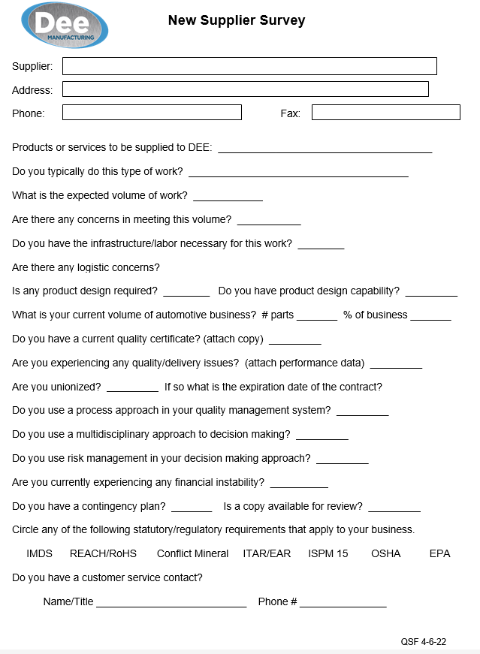
Appendix V (Scorecard)

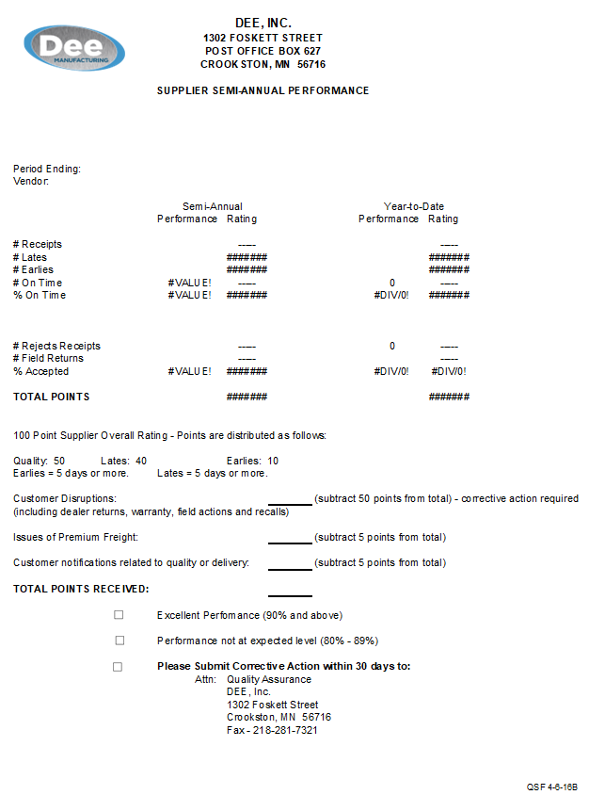
Appendix VI (Sample Production Control Plan)

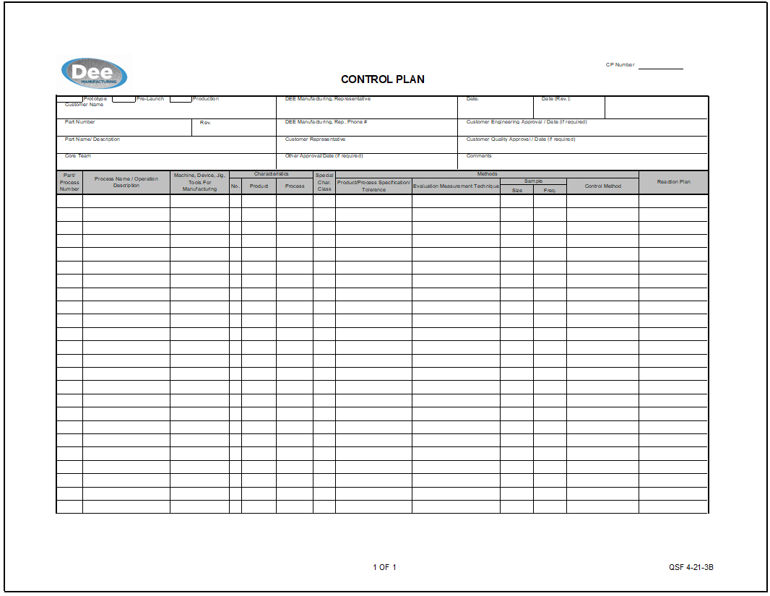

Appendix VII (Sample Process Failure Mode and Effects Analysis (PFMEA)

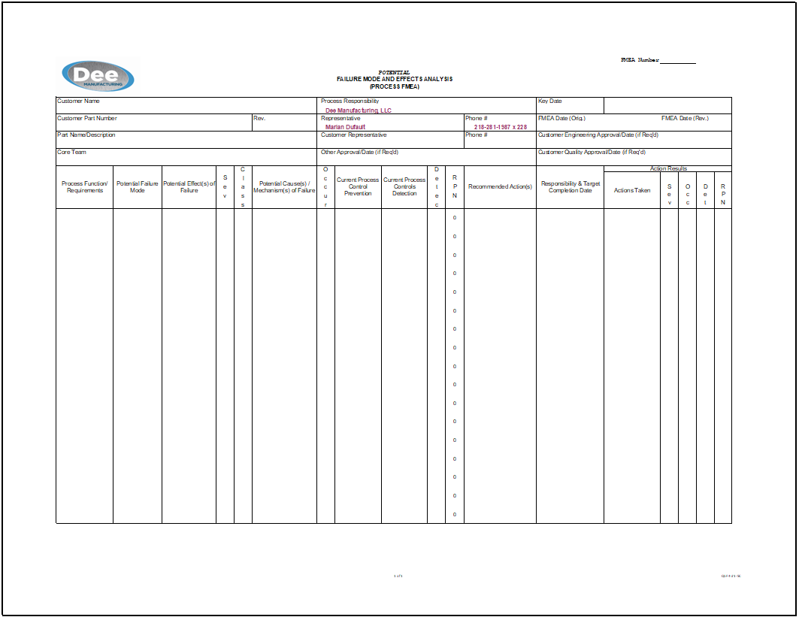

13.0 Revision Page

DATE | REV | DESCRIPTION

